Chapter-1

Organizational Behaviour

**What is Business Psychology?**

**-Psychology** is the science that seeks to measure, explain, and sometimes change the behavior of humans and other animals.

Business Psychology is **an applied science that investigates how to make people and organizations more effective**. It uses social scientific research methods to study people, workplaces and organizations with the goal of improving organizational effectiveness, employee well-being, and productivity.

**O B skills are important because…**

* “Good places to work” have better financial performance.
* Better interpersonal skills result in lower turnover of quality employees and higher quality applications for recruitment.
* There is a strong association between the quality of workplace relationships and job satisfaction, stress, and turnover.
* It fosters social responsibility awareness.

**Manager**: someone who gets things done through other people in organizations.A manager is an individual within an organization who is responsible for overseeing and coordinating the activities of a group of employees or a specific department to achieve organizational goals and objectives. Managers play a crucial role in planning, organizing, leading, and controlling the resources and activities of their team or department.

Key responsibilities of a manager typically include:

**Planning:** Managers are involved in setting goals, objectives, and strategies for their team or department. They develop plans and allocate resources to achieve organizational targets effectively.

**Organizing:** Managers organize the structure and resources of their team or department to ensure that tasks are delegated appropriately, roles are defined clearly, and workflows are efficient. They may design workflows, establish reporting relationships, and allocate responsibilities among team members.

**Leading:** Managers provide leadership and direction to their team members, motivating them to achieve high performance and excellence. They communicate organizational goals, provide guidance and support, and inspire employees to work collaboratively towards common objectives.

**Coordinating:** Managers coordinate the activities of their team members to ensure that tasks are completed on time and in accordance with organizational standards and procedures. They facilitate communication, resolve conflicts, and ensure that resources are utilized effectively.

**Controlling:** Managers monitor and evaluate the performance of their team or department to ensure that goals are being met and organizational standards are being maintained. They track progress, analyze performance data, and implement corrective actions as needed to address deviations from targets.

**Organization**: a consciously coordinated social unit composed of two or more people that functions on a relatively continuous basis to achieve a common goal or set of goals.

An organization is a structured group of individuals who come together to achieve specific goals or objectives. Organizations can take various forms, including businesses, non-profit organizations, government agencies, educational institutions, and social or community groups.

#Henry Mintzberg, a prominent management theorist, identified ten managerial roles that managers commonly perform within organizations. These roles are categorized into three main groups: interpersonal roles, informational roles, and decisional roles.

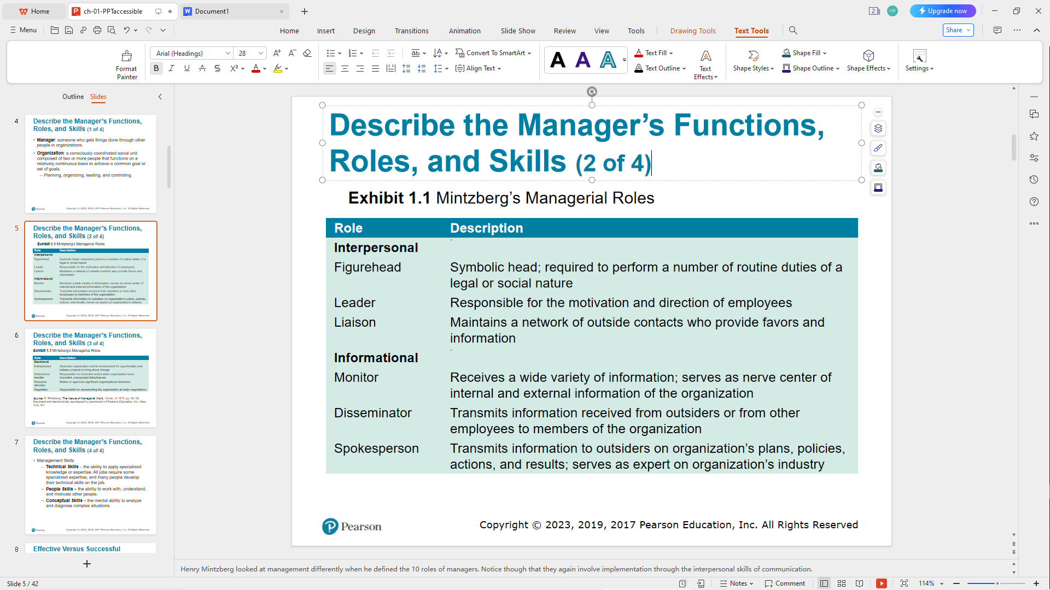

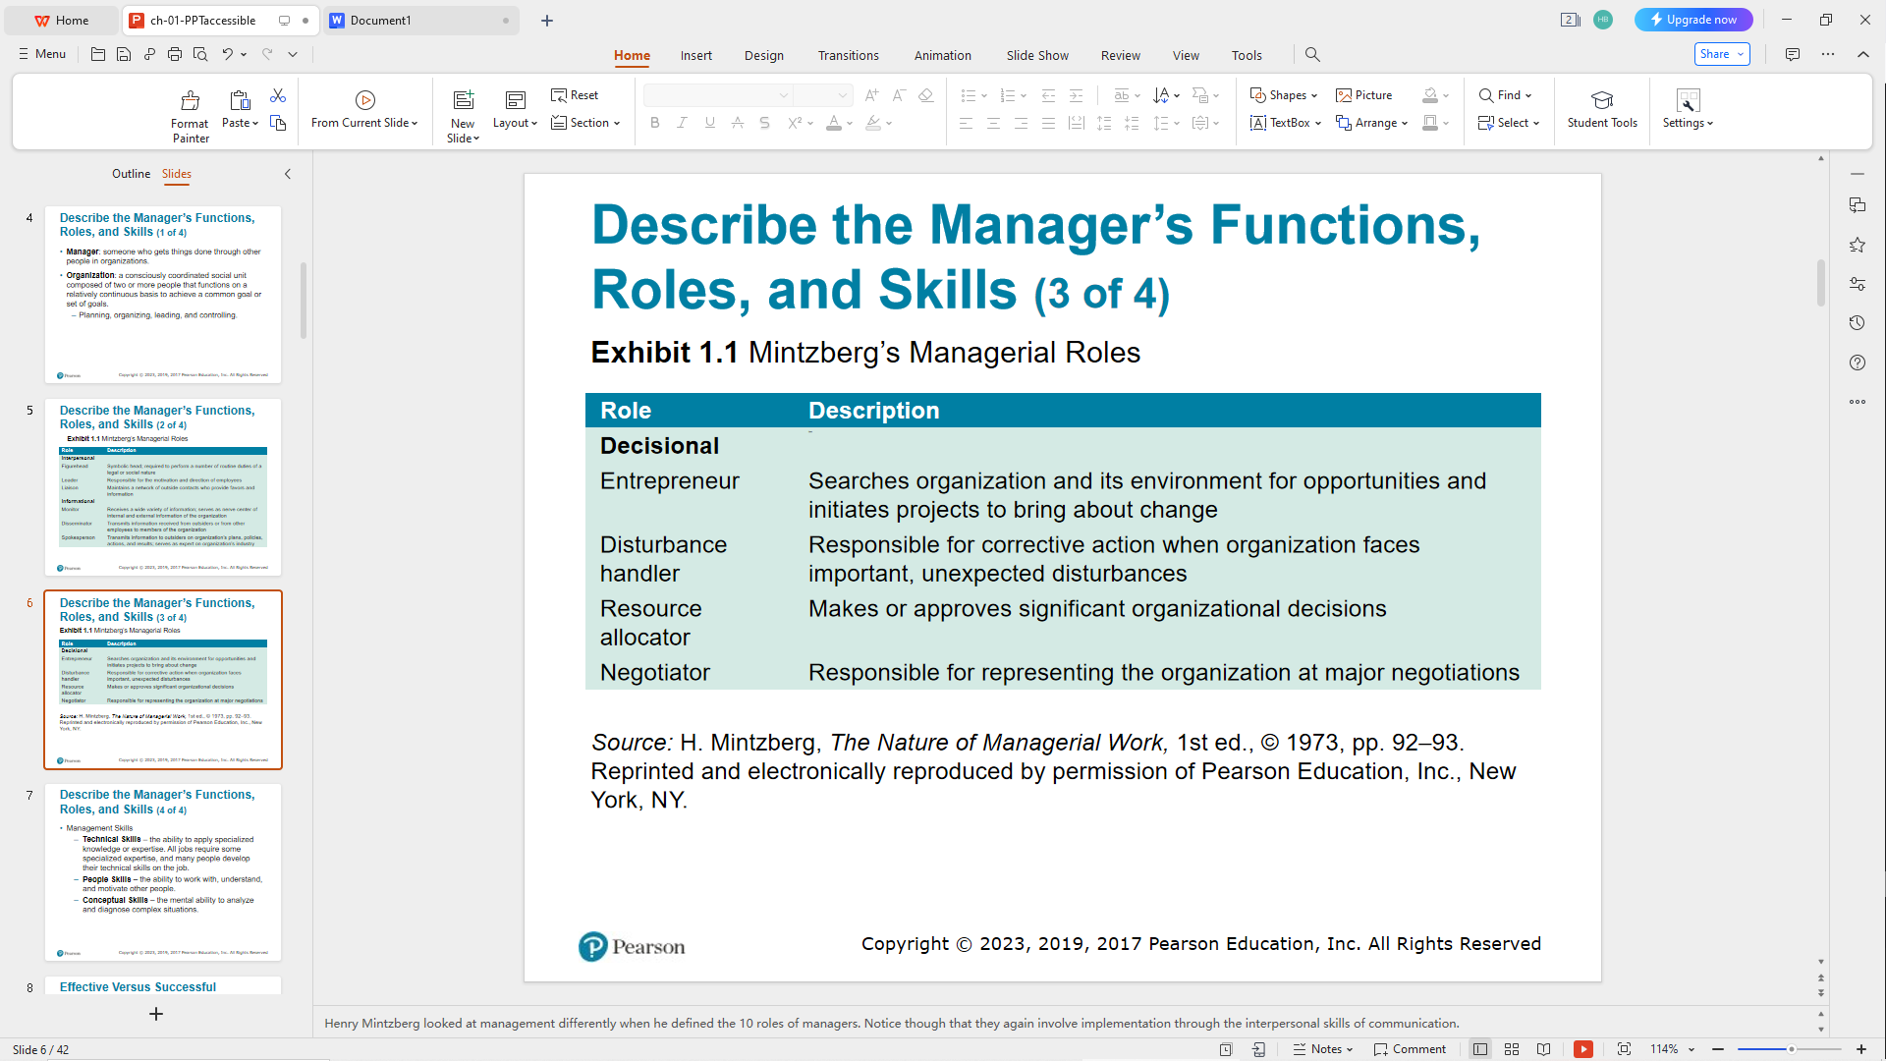

**Management Skills**

* Technical Skills – the ability to apply specialized knowledge or expertise. All jobs require some specialized expertise, and many people develop their technical skills on the job.
* People Skills – the ability to work with, understand, and motivate other people.
* Conceptual Skills – the mental ability to analyze and diagnose complex situations.

Luthans and his associates found that all managers engage in four managerial activities:

1. Traditional management
2. Communication
3. Human resource management
4. Networking

**Successful Managers:**

* 1. A successful manager is typically measured by tangible outcomes or achievements, such as meeting targets, increasing revenue, or receiving promotions.
  2. Success is often quantifiable and can be assessed based on specific metrics or performance indicators.
  3. Successful managers may focus more on achieving short-term goals or demonstrating visible accomplishments.

**Effective Managers:**

* 1. An effective manager is measured by their ability to achieve organizational goals while also fostering a positive work environment and developing their team members.
  2. Effectiveness is more holistic and considers the long-term impact of a manager's actions on the organization, team, and individual employees.
  3. Effective managers prioritize building strong relationships, promoting teamwork, and empowering their employees to achieve success.

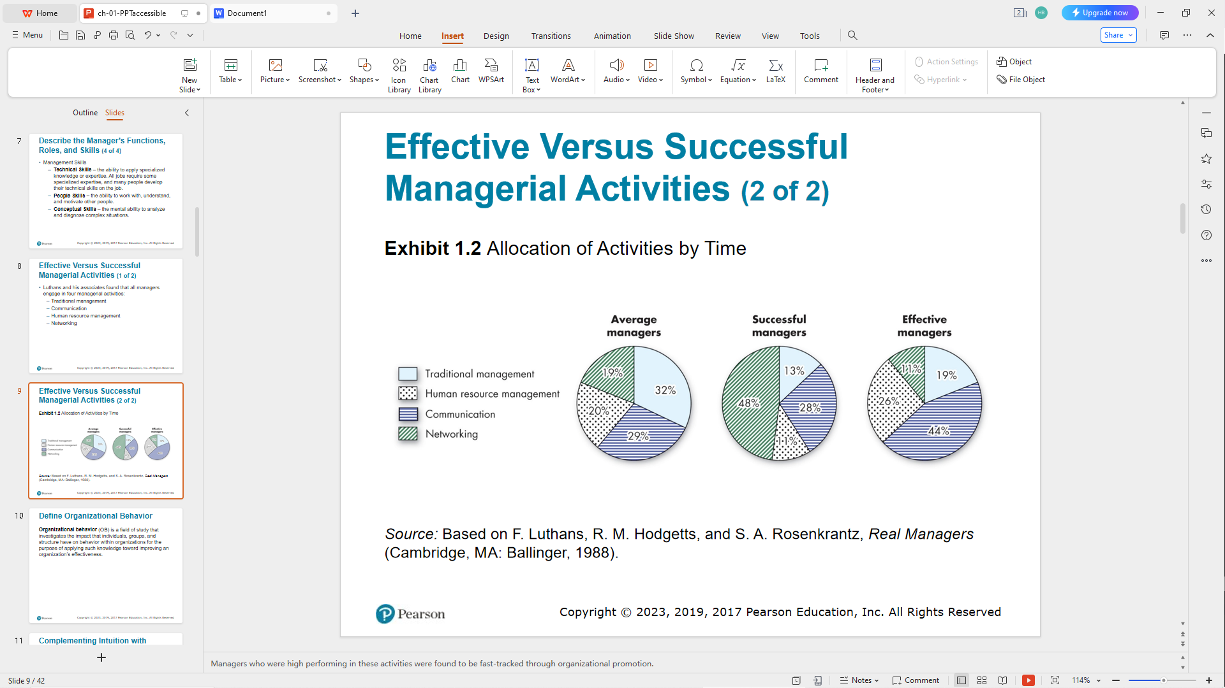

**What is Organizational Behaviour?**

-Organizational behavior (O B) is a field of study that investigates the impact that individuals, groups, and structure have on behavior within organizations for the purpose of applying such knowledge toward improving an organization’s effectiveness.

These concepts relate to different approaches and perspectives on understanding and managing behavior in organizational settings:

* Systematic Study of Behavior

Behavior generally is predictable if we know how the person perceived the situation and what is important to the person.

* Evidence-Based Management (E B M)

Complements systematic study.Argues for managers to make decisions based on evidence.

* Intuition

Systematic study and E B M add to intuition, or those “gut feelings” about “why I do what I do” and “what makes others tick.”

If we make all decisions with intuition or gut instinct, we’re likely working with incomplete information.

**Big data** refers to extremely large and complex datasets that exceed the capabilities of traditional data processing methods and tools to capture, manage, and analyze within a reasonable time-frame.

* Background:

The use of Big Data for managerial practices is a relatively new area, but one that holds convincing promise.

* Current Usage:

The reasons for data analytics include predicting any event, detecting how much risk is incurred at any time, and preventing catastrophes.

* New Trends:

The use of Big Data for understanding, helping, and managing people is relatively new but holds promise.

* Limitations:

Use evidence as much as possible to inform your intuition and experience.

**Major Behavioral Science disciplines that contribute to OB:**

-Organizational behavior is an applied behavioral science that is built upon contributions from a number of behavioral disciplines:

* **Psychology**-seeks to measure, explain, and sometimes change the behavior of humans and other animals.
* **Social psychology**-blends the concepts of psychology and sociology.
* **Sociology**-studies people in relation to their social environment or culture.
* **Anthropology**-is the study of societies to learn about human beings and their activities.

There are few, if any,simple and universal principles that explain **organizational behavior.**

**-Contingency variables:** situational factors are variables that moderate the relationship between the independent and dependent variables.

**Challenges and Opportunities of OB concepts:**

* Managing workforce diversity

-Workforce diversity – organizations are becoming more heterogeneous in terms of gender identity, age, race, ethnicity, sexual orientation, and other characteristics

-Workforce inclusion – creating and maintaining workplaces that support and leverage their members’ diversity.

* Responding to globalization

-Increased expatriate assignments.

* Expatriate – person who works outside their native country.

-Working with people from different cultures.

* Using technology and social media at work

-Policies on accessing social media at work.

* When, where, and for what purpose.

-Impact of social media on employee well-being.

-“Always-on” culture of the virtual workplace.

* Making virtual workers a part of the team.
* Achieving work-life balance.
* Improving ethical behavior

-Ethical dilemmas and ethical choices are situations in which an individual is required to define right and wrong conduct.

-Good ethical behavior is not so easily defined.

-Managers need to create an ethically healthy climate.

* Ethics training
* Practicing corporate social responsibility (C S R)

-Environmental sustainability initiatives

-Nonprofit work

-Volunteering

-Charitable giving

-Sustainability training and development

* Triple bottom line: people, planet, revenue
* Creating a positive work environment

**-Positive organizational scholarship** is concerned with how organizations develop human strength, foster vitality and resilience, and unlock potential.

-This field of study focuses on employees’ strengths versus their limitations, as employees share situations in which they performed at their personal best.

* Responding to the Gig Economy

-Independent and autonomous work

* “a company of one”
* Managing crises

-The differences between good and bad management can be the differences between profit and loss or survival or failure.

-How can we use our knowledge of workplace behavior to inform decision making during crises?

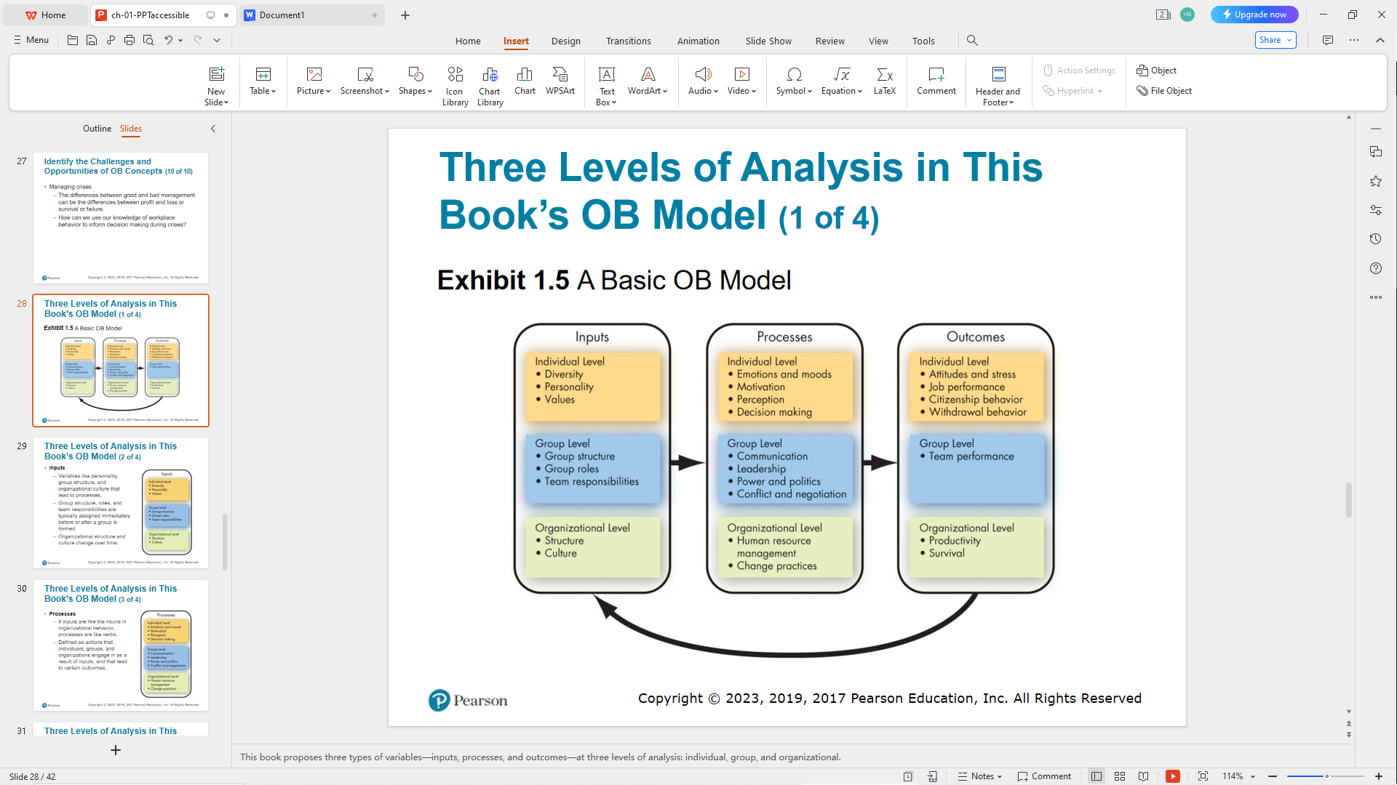

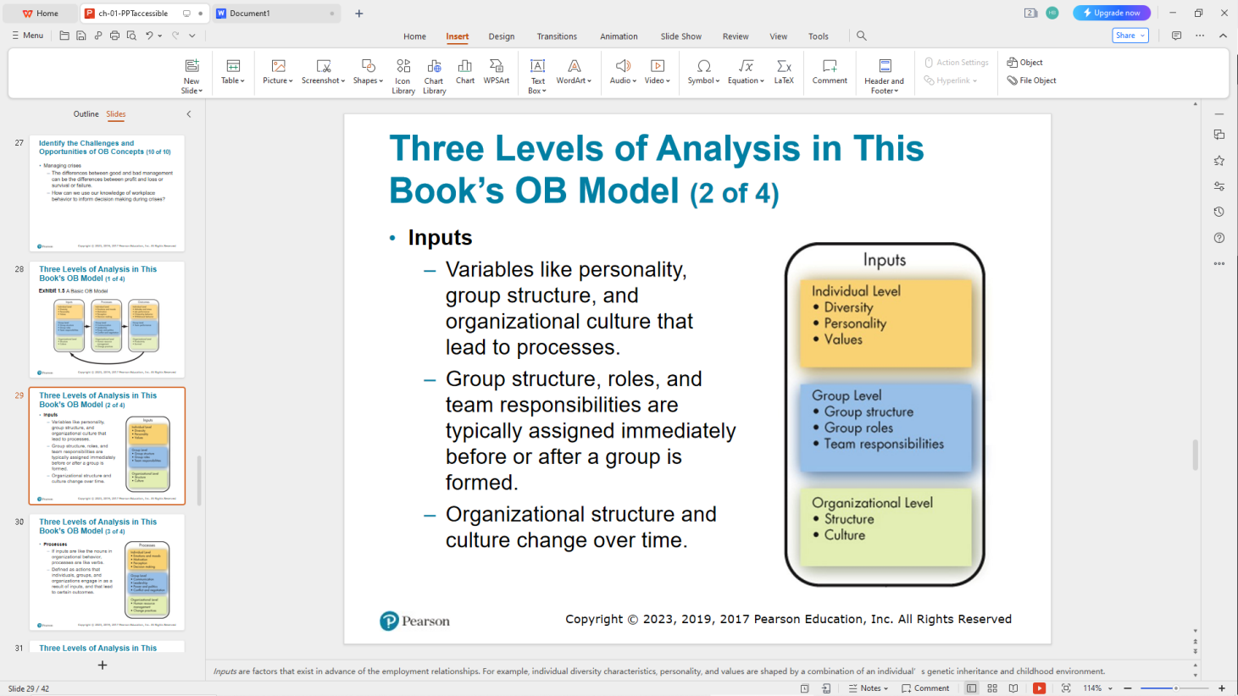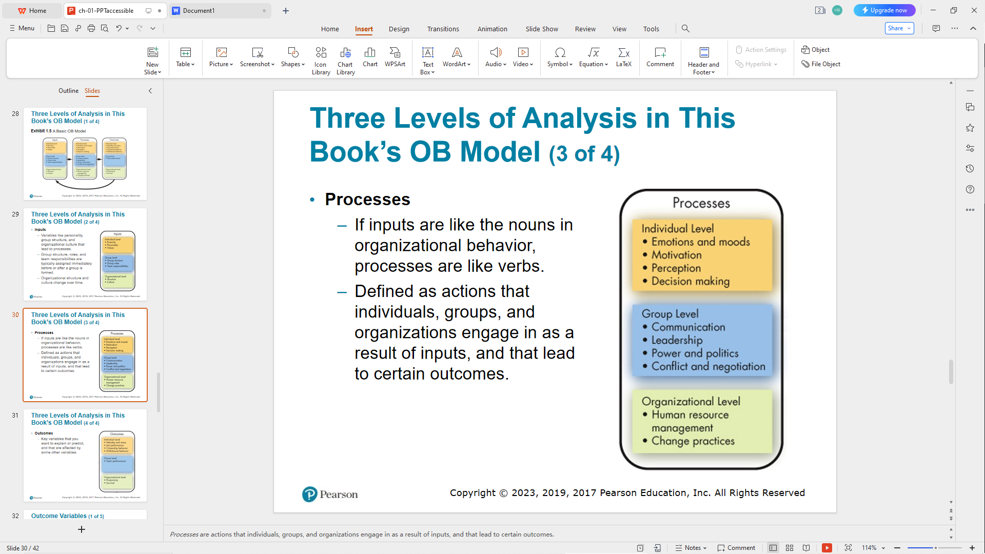

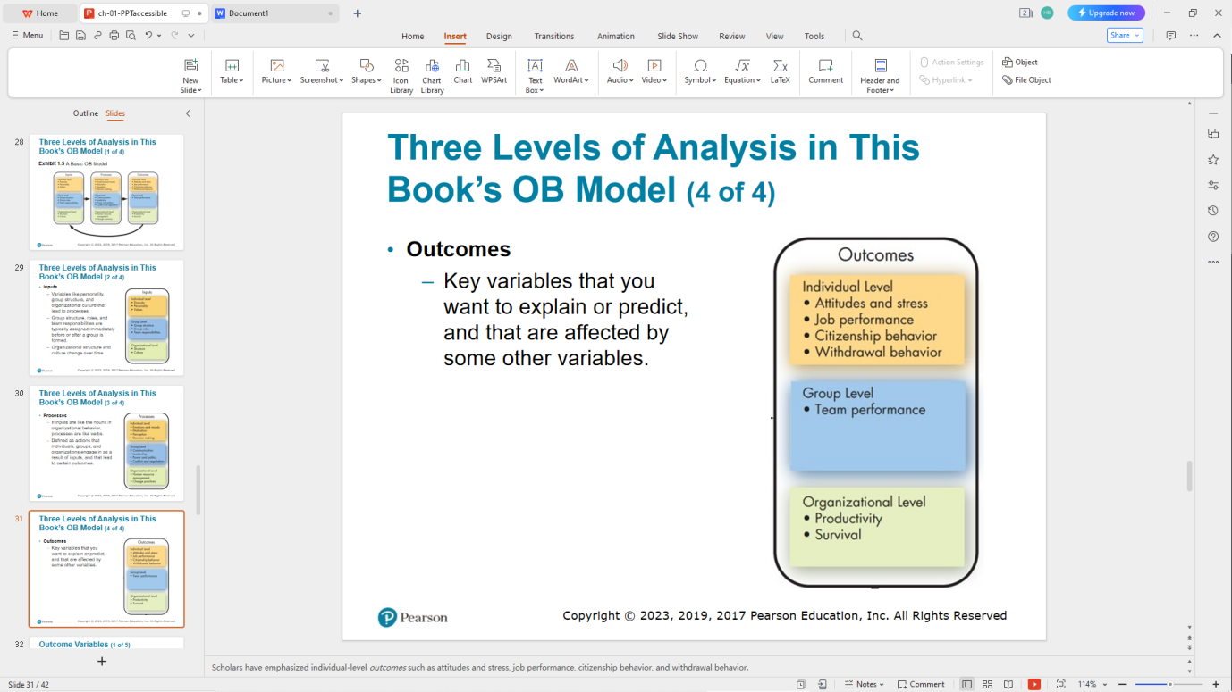

**Outcome Variables**

* Attitudes and stress

-Employee attitudes are the evaluations employees make, ranging from positive to negative, about objects, people, or events.

-Stress is a psychological process that occurs in response to environmental pressures.

* Job performance

-The total value of your contributions to an organization through your behaviors reflects your level of job performance.

* Task performance

-The combination of effectiveness and efficiency at doing your core job tasks is a reflection of your level of task performance.

* **Organizational citizenship behavior (O C B)**

The discretionary behavior that is not part of an employee’s formal job requirements, and that contributes to the psychological and social environment of the workplace, is called organizational citizenship behavior.

* Withdrawal behavior

-Withdrawal behavior is the set of actions that employees take to separate themselves from the organization.

* Team performance

-Team performance is the quantity and quality of a team’s work output.

* Productivity

-An organization is productive if it achieves its goals by transforming inputs into outputs at the lowest cost. This requires both effectiveness and efficiency.

* Survival

-The final outcome is organizational survival, which is simply evidence that the organization is able to exist and grow over the long term.

**Employability Skills:**

* Critical thinking and creativity
* Communication
* Collaboration
* Self-management
* Social responsibility
* Leadership
* Career management

**Implications of a Manager**

* Resist the inclination to rely on generalizations; some provide valid insights into human behavior, but many are erroneous(being wrong or inaccurate).
* A nuanced(having or characterized by subtle and often appealingly complex qualities, aspects, or distinctions) understanding of the situation is often needed to reach the best solutions. Try to understand the people involved and the context. From there, try and figure out what works, what does not work, and any contingencies that qualify these practices.
* Strive for evidence-based solutions to problems and evaluate your hunches and intuition critically.
* Work on your people skills to better interact with peers, work on teams more effectively, and both lead and manage your followers to do great things.
* Improve your technical skills and conceptual skills through training and staying current with O B trends like big data and fast data.
* O B can improve your employees’ work quality and productivity by showing you how to empower your employees, design and implement change programs, improve customer service, and help your employees balance work–life conflicts.